PETER RABBIT’S BIRTHDAY JACKET COMPETITION
Peter Rabbit is celebrating his 120th birthday this year. He loves his blue jacket, but he’d love a special one to wear to his birthday party. Can you design him a snazzy new jacket?
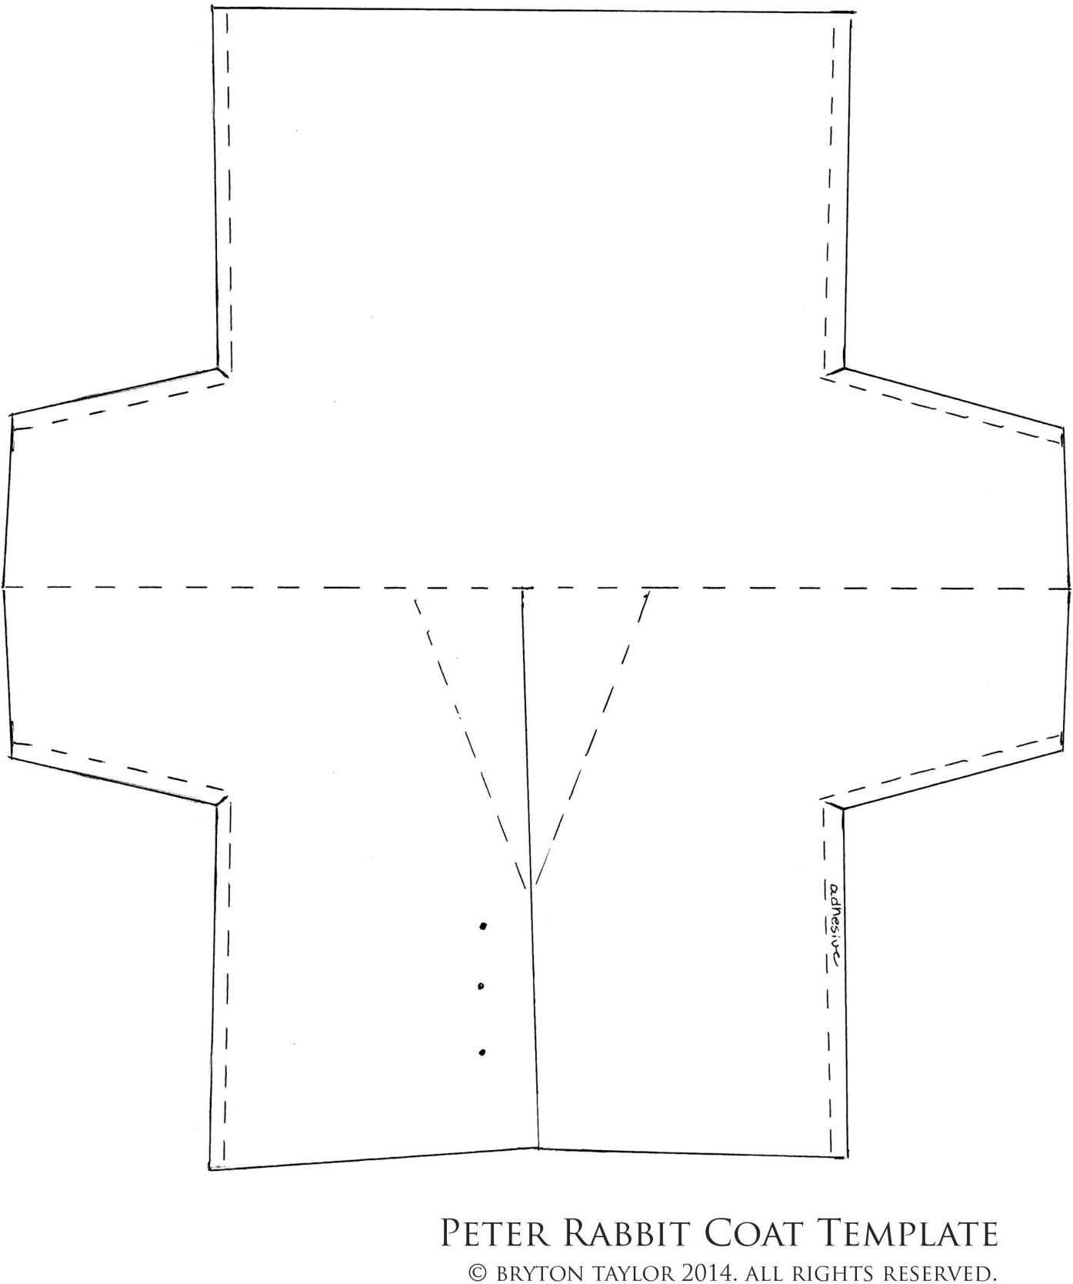
The Prizes
1st prize:
- The winning design will be reproduced by local artist Simon Jardine and added to our large mural in the Runway Gallery for the duration of The World of Peter Rabbit™ Storytime Trail at The Base Greenham (Sat 30 Jul – Sun 25 Sep).

- Family ticket to Beale Wildlife Park in Pangbourne (worth £52), a stunning 350 acre riverside adventure with 160 wildlife species from all over the world.

- A copy of Peter Rabbit Tales – Happy Birthday (Board book)
- The winning design will also be displayed on our website and social media platforms.
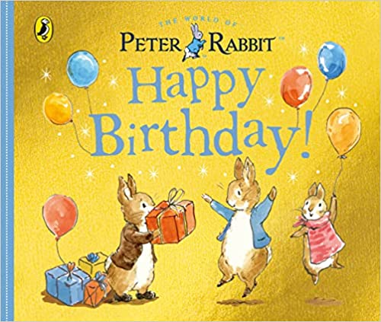
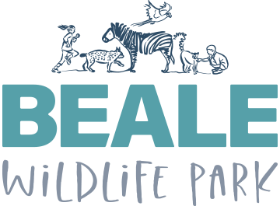
Runners-up
We will pick 5 runners up whose designs will be displayed in our Runway Gallery for the duration of The World of Peter Rabbit™ Storytime Trail at The Base Greenham (Sat 30 Jul – Sun 25 Sep).

To Enter
Simply email a photo of your finished artwork to admin@ thebasegreenham.co.uk, before 8pm on Sunday 10 July, with the subject line Peter Rabbit Birthday Jacket Competition, and tell us the child’s name and age. You’re welcome to use the template, or to create your own.
Please visit our website to download more copies of this document: www.thebasegreenham.co.uk/peterrabbit

The Rules
- We must receive entries for the competition by 8pm on Sunday 10 July 2022.
- Please don’t post your artwork to us, we’re only accepting email entries and we’ll be unable to return any artwork sent in by post.
- When taking a photo of your artwork to send to us, please make sure you use natural lighting. Dark or unnatural light can result in distorted image colour/appearance.
- We will aim to inform all winners within 3 days of the closing date.
- The competition is not open to employees of The Base Greenham, Corn Exchange Newbury or Beale Wildlife Park, their family members or anyone else connected to the prize draw.
- All entrants must be under-16 and should ask permission from a parent or guardian before entering.
- Prizes are non-transferable and no cash alternative will be offered.
- Beale Park family ticket must be used by 16/05/23

